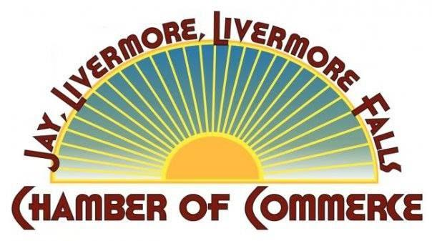
P.O. Box 458 Livermore Falls, Maine 04254
2023 Membership Application
Please assist us in keeping membership records up to date by completing the application and mailing it back to the JLLF Chamber of Commerce

Business Name: _____________________________________________________
Contact Name: ___________________________ Title: _____________________
Email: ________________________________________________________________
Business Street Address: ________________________________________________
Mailing Address (if different): ___________________________________________
Primary Phone #: __________________Secondary Phone #:___________________
Business Email: _____________________________________________________
Web Address: _____________________________________________________
Brief Description of Business: ___________________________________________
______________________________________________________________________
TOTAL Number of Employees (including owner): _________

From the following pages, please calculate your total:
 | Pay Now | Invoice Me Later | Date to Invoice | Must be Invoiced by:
1. Annual Dues Total |  | XXXX | XXXX | XXXXX
2. 2023 Breakfast Meetings Total |  | XXXX | XXXX | XXXXX
3. 2023 Scholarship Golf Tournament Sponsor Total |  |  |  | 5/01/23
4. 2023 Apple Pumpkin Sponsor Total |  |  |  | 8/01/23
5. 2023 Livermore Falls History Night & Cruise-in |  |  |  | 4/01/23
6. 2023 Olde Fashioned Christmas Festival |  |  |  | 10/01/23
Total: _______________
_______ Check here if you would like us to contact you to pay with a Credit Card.
_______ Check here if you are including a check for the Total noted above.

1. 2023 Annual Dues
Membership Type | Cost | Select One
Citizen Supporter | $35
Civic & Social Organizations | $60
Non-Profit Organizations | $60
1 Owner (only one person involved ) | $125
2 to 5 Employees (including owner) | $150
6 to 10 Employees | $170
11 to 25 Employees | $195
26 to 100 Employees | $220
101 to 250 Employees | $360
Over 250 Employees | $800
Annual Dues Total: ___________________
2. 2023 Breakfast Meetings
Breakfast Meetings are a great way to start your day. This is an opportunity to network with other businesses, display (advertise) your business’ banner, learn about other Chamber Members with the “Member in the Spotlight” presentation, and enjoy informational guest speakers.
Pay now for ten 2023 Breakfast Meetings and receive one free breakfast.**

Unless otherwise noted, Breakfast is held at the Community Center located at St. Rose parish in Jay.
*Please note that there is no Breakfast Meeting in January or July.

If you would like to take advantage of paying for the 2023 Breakfast Meetings upfront, please fill out the following:
- Number of Employees ___ X $108 = _______________

Take advantage of being a Breakfast Sponsor! First come, first served! We will contact you to schedule your preferred month or the next available spot.(includes one person for breakfast)
- _____ I would like to reserve my spot as a Breakfast Sponsor. $200_

Breakfast Meetings Total (a + b) = ___________________________

3. 2023 Scholarship Fund Golf Tournament

We are excited to host our Annual Scholarship Fund Golf Tournament in May and want to invite you to take advantage of past Sponsorship pricing by signing up ahead! Pay now or tell us when to invoice you!

Sponsorship Level | Cost | Select One (or more)
Tournament Sponsor (only one) | $500
Putting Contest Sponsor | $300
Casino Hole Sponsor | $300
Banquet Sponsor*** | $200
19th Hole Sponsor | $200
Golf Cart Sponsor | $200
Longest Drive Sponsor | $200
Closest to the Pin Sponsor | $200
Tee Box & Greens Sponsor | $150

____ I would like to donate a gift to use in the raffle.

2023 Scholarship Golf Tournament Sponsor Total:_______________

4. 2023 Apple Pumpkin Festival

Each year the Apple Pumpkin Festival grows larger and larger, and we are anxious to see what 2023 brings! Take advantage of past Sponsorship pricing by signing up ahead! Pay now or tell us when to invoice you! It is as easy as that!
Sponsorship Level | Cost | Select One
Friends of Apple Pumpkin | Up to $149.99
Business/Corporate Sponsor | $150 - $499.99
Event Underwriter | $500 – $999.99
Major Underwriter | $1000 and up
**____ I would like to donate a gift to use in the raffle.

Apple Pumpkin Festival Sponsor Total: _______________

5. 2023 Livermore Falls History Night and Cruise-in

There is something special about the Livermore Falls History Night and Cruise-in! This nostalgic night brings those memories of the classics to the forefront of downtown Livermore Falls!

I would like to donate to this event: __$25 __$50 __$100 __other $______

6. Olde Fashioned Christmas Festival
Celebrating the spirit of the season and giving back to charity.
I would like to sponsor the event- $500_____
I would like to sponsor Hot Cocoa Station-$200_____
I would like to sponsor a tree - $80______

